***Final Project Report***

***On­­­***

**3-D Multiplayer Game(Tic-Tac-Toe)**

**Submitted for the requirement of**

**Project course**

BACHELOR OF ENGINEERING

**COMPUTER SCIENCE & ENGINEERING**



**Submitted to: Priyanka Sharma(E6197) Submitted By: Sahul Kr. Parida(20BCS4919)**

**(Project Supervisor) Saksham Thakur(20BCS4970)**

**Sudhanshu Kumar(20BCS4953)**

**Co-Supervisor Signature**

**Archana Kumari (E13569)**

**DEPARTMENT OF COMPUTER SCIENCE & ENGINEERING**

**CHANDIGARH UNIVERSITY, GHARUAN**

**November 2022**

**BONAFIDE CERTIFICATE**

Certified that this project report **“3-D Multiplayer Game”** is the bonafide work of **“Sahul Kumar Parida(20BCS4919) of WM904-B, Saksham Thakur(20BCS4970) of WM612-A and Sudhanshu Kumar(20BCS4905) of NTPP_WM701-A”** who carried out the project work under my/our supervision.

**SIGNATURE SIGNATURE**

***(SUPERVISOR*) (*HEAD OF THE***

***DEPARTMENT)***

Submitted for the project viva-voice examination held on

### INTERNAL EXAMINER EXTERNAL EXAMINER

### ACKNOWLEDGEMENT

We express my heartfelt and sincere gratitude to GOD Almighty, for his blessings for the successful completion of our project work without any hindrance.

The support and help of a few people not only enabled us to complete our work successful and also made it a worthwhile experience. I thank the management for providing all the support and facilities.

We are grateful to our Supervisor, Priyanka mam and Co-Supervisor, Archana mam for their encouragement and support. We are greatly indebted to them for their valuable suggestions and ideas that has been the source of inspiration throughout our project work.

We also express my sincere thanks to my parents for their guidance and wholehearted

support.

We convey my sincere thanks to all other faculties for their help and encouragement. I thank

all my friends who have helped me during the work, with their inspiration and co-operation.

Once again I convey my gratitude to all those persons who had directly or indirectly

influenced on the work.

**TABLE OF CONTENT**

|  |  |  |
| --- | --- | --- |
| Sr no. | Topic | Page No. |
|  | ABSTRACT | 5 |
|  | GRAPHICAL ABSTRACT | 5 |
| 1 | Introduction | 6 - 10 |
| 2 | Literature Review | 11 - 12 |
| 3 | Methodology | 13 - 20 |
| 4 | Implementation and Result | 21 - 26 |
| 5 | Conclusion and Discussion | 27 - 29 |
| 14 | References | 30 |

**ABSTRACT**

Undeniably, 3d video games are very popular in today's video game fans. The graphics and layout in the game have proven to attract players with a sense of satisfaction while playing. The more difficult obstacles make the player thirst for the upcoming challenge to get past each level in the game. "Role-Playing Games" or RPG is a video game concept adopted by a handful of video game developers for players so players can feel as though they are in the game. It allows players to create, design, choose or decorate characters or be known as "avatars" that represent players in the game. This concept not only allows the player to control the character but can also upgrade attribute given to the character to allow it to pass the barrier in the video game. In conclusion, these concepts and ideas can be adopted everywhere to promote a place so players can feel the atmosphere their while playing the video game.

**GRAPHICAL ABSTRACT**

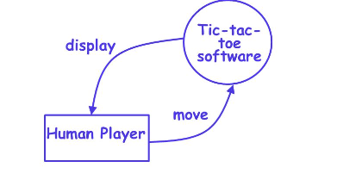

1. **INTRODUCTION**

Tic-tac-toe also known as noughts and crosses is a paper and pencil game for two players, who take turns marking the spaces in a 3 x 3 grid traditionally. The player who succeeds in placing three of their marks in a horizontal, vertical or diagonal row wins the game. It is a zero-sum of perfect information game. This means that it is deterministic, with fully observable environments in which two agents act alternately and the utility values at the end of the game are always equal and opposite. Because of the simplicity of tic-tac-toe, it is often used as pedagogical tool in artificial intelligence to deal with searching of game trees. The optimal move for this game can be gained by using minimax algorithm, where the opposition between the utility functions makes the situation adversarial, hence requiring adversarial search supported by minimax algorithm with alpha beta pruning concept in artificial intelligence.

# **1.1 Project Background**

3D Tic-Tac-Toe is the newest game. We want our game to bring the player community together. The system was envisioned to be a place where users can interact with each other, while having fun playing a complete redesign on the traditional board game. The game was developed using the original game model with added complexity, interactivity and competitiveness. We added up to 4 players. A new redesign and interactive 3D board game. Customizable user avatars for players to express themselves and tout others. An interactive chat. Tournaments with player alliances and power charms to add a twist to the gameplay. The game will be available in mobile and web platforms. Our high fidelity prototype included the games three main components, the game lobby, a game play room and a score screen. We hope our game inspires other developers to transform traditional board games into fun and interactive software.

# **1.2 Problem Statement**

There are many problems occur among the player which influent by video games:

* Too many games are for entertainment only.
* Lack of promotion platform.
* Violent inside video game are uncontrollable.

# **1.3 Problem Identification**

Tic tac toe game has 16 cells for a 4x4 grid. The two players with their respective marks as ‘X’ and ‘O’ are required to place their marks in their turns one by one. Once the cell is occupied by a mark it cannot be used again. The game is won if the agent is able to make a row or column or a diagonal occupied completely with their respective marks. The game terminates once the winning situation is gained or the cells are fully occupied. The problem specification for this game is given below:

Problem: Given a 4x4 grid, the agents has to find the optimal cell to fill with respective marks.

Goals: To find the optimal cell to fill with respective marks and in order to win the game, the cell must be filled such that one of the following criteria is satisfied:

1. A row is completely filled by a mark ‘X’ or ‘O’.
2. A diagonal is completely filled by a mark ‘X’ or ‘O’.
3. A column is completely filled by a mark ‘X’ or ‘O’.

If these criteria are not satisfied by both the agents, the game is terminated with a tie situation.

Constraints:

1. Once the cell is occupied by a mark, it cannot be reused.
2. Agents place the mark alternatively. So, consecutive moves from any agent is not allowed.

# **1.4 Objective**

1. To develop Artificial intelligence-based tic-tac-toe game for human Vs AI by implementing minimax algorithm with adversarial search concept.
2. To analyze the complexity of minimax algorithm through 4x4 tic tac toe game.
3. To study and implement alpha-beta pruning concept for improved speed of searching the optimal choice in tic-tac toe game.
4. To study optimizing methods for alpha-beta pruning using heuristic evaluation function.

# **1.5 Scope and Target User**

Gaming application is an application that gives a new trend in the world. This game will ensure the people know about the campus comprehend into an interesting storyline. The storyline that can help the player to solve the problem and challenges arise as they play the game.

This is simulation game; the player needs to complete the to-do task (seem they being freshman inside the campus) to complete one level. Player need to explore themselves the game to complete the task, however there will be hint or guide for the player.

# **1.6 Limitation**

As by doing this project, we found there are several limitations of the work:

* This game using windows and android platforms only.
* This game focus on Virtual 3-D World.
* The user can control this game using console or keyboard.
* This game limit for 3 levels and free mode (free exploration around the map of

Virtual World).

# **1.7 Gantt Chart**

|  |  |  |  |  |  |  |  |  |  |  |  |  |  |  |  |
| --- | --- | --- | --- | --- | --- | --- | --- | --- | --- | --- | --- | --- | --- | --- | --- |
| Task name | AUGUST | | | | SEPTEMBER | | | |  | OCTOBER | | |  | NOVEMBER | |
| 1 | 2 | 3 | 4 | 5 | 6 | 7 | 8 | 9 | 10 | 11 | 12 | 13 | 14 | 15 |
| Topic Discussion  and  Determination |  |  |  |  |  |  |  |  |  |  |  |  |  |  |  |
| Project Title Proposal |  |  |  |  |  |  |  |  |  |  |  |  |  |  |  |
| Proposal writing |  |  |  |  |  |  |  |  |  |  |  |  |  |  |  |
| Proposal writing –  Literature Review |  |  |  |  |  |  |  |  |  |  |  |  |  |  |  |
| Proposal Progress  Presentation &  Evaluation |  |  |  |  |  |  |  |  |  |  |  |  |  |  |  |
| Discussion |  |  |  |  |  |  |  |  |  |  |  |  |  |  |  |
| Correction Proposal |  |  |  |  |  |  |  |  |  |  |  |  |  |  |  |
| Proposed Solution  Methodology |  |  |  |  |  |  |  |  |  |  |  |  |  |  |  |
| Proof of Concept |  |  |  |  |  |  |  |  |  |  |  |  |  |  |  |
| Drafting Report of the  Proposal |  |  |  |  |  |  |  |  |  |  |  |  |  |  |  |
| Submit draft of report supervisor |  |  |  |  |  |  |  |  |  |  |  |  |  |  |  |
| Correction Report |  |  |  |  |  |  |  |  |  |  |  |  |  |  |  |
| Final Report Submission |  |  |  |  |  |  |  |  |  |  |  |  |  |  |  |

Table 1.1: Gantt Chart

# **1.8 Data Flow Diagrams**

Tic-tac-toe is a computer game in which a human player and the computer make alternative moves on a 3×3 square. A move consists of marking previously unmarked square. The player who first places three consecutive marks along a straight line on the square (i.e. along a row, column, or diagonal) wins the game. As soon as either the human player or the computer wins, a message congratulating the winner should be displayed. If neither player manages to get three consecutive marks along a straight line, but all the squares on the board are filled up, then the game is drawn. The computer always tries to win a game.

**Tic-Tac-Toe**

**Software**

**0**

**Human Player**

**display**

**move**

**(**

**a)**

**b)**

**(**

**val**

**idate-**

**move**

**0.2**

**play-**

**move**

**0.**

**3**

**check-**

**winner**

**0.**

**4**

**display-**

**board**

**0.**

**1**

**board**

**move**

**result**

**game**

Fig (a), (b) Level 0 and Level 1 DFD for Tic-Tac-Toe game.

It may be recalled that the DFD model of a system typically consists of several DFDs: level 0, level 1, etc. However, a single data dictionary should capture all the data appearing in all the DFDs constituting the model. Figure 5.2 represents the level 0 and level 1 DFDs for the tic-tac-toe game.

**2. LITERATURE REVIEW**

# **2.1 Introduction**

A literature review discusses published information in a particular subject area, and sometimes information in a particular subject area within a certain time period. It can be just a simple summary of the sources, but it usually has an organizational pattern and combines both summary and synthesis. People can use it as a guideline or a sample to upgrade or to develop a new better system compared to the old one.

The main objective of literature review is:

* It presents the literature in an organize way.
* It surveys the literature in your chosen area of study.
* It synthesis the information in that literature into a summary.
* It critically analyses the information gathered by identifying gaps in current knowledge; by showing limitations of theories and points of view; and by formulating areas for further research and reviewing areas of controversy.

# **2.2 Literature Review (based on game concept)**

There are a few categories on developing game concept. The following sections deal with each of the categories in detail.

**2.2.1 Video Games and Interactive Storytelling**

Interactive storytelling is a topic tightly related to this thesis, because every quest needs a story, and interactive storytelling can be the instrument to produce them. The core of this concept is the ability of the player to influence the narrative by his actions, and the two main kinds of interactive storytelling are based on who, or what, creates the narrative– either the virtual characters in the game, or the story itself.

**2.2.2 Character–Driven Storytelling**

In the character-driven subtype of storytelling, the story is not controlled or enforced in any way, but instead is generated by the characters being in the situations and taking actions based on their motivations and subsequent decisions. The possibility to alter the characters’ decisions by altering the environment or giving them advice was presented, with the result of changing the action the character takes, ultimately leading to a change in the ending of the story.

**2.2.3 Story–Driven Storytelling**

In the story-driven storytelling, the story is seen as a sequence of actions controlled by another entity. When the user makes a difference in the world, either by interaction or the lack of it, the controller takes notice and adjusts the story and its actions, and that ultimately leads to a change of the narrative course.

# **2.3 Chapter Summary**

This chapter discussed literature review that has been reviewed during feasibility studies. the literature review helps a developer to discover the problem of the previous research or exciting project which is needed to improve and overcome in this game development. furthermore, it also helps to gain understanding about the game that undergoes the development process.

As a conclusion, the Game Development Life Cycle (GDLC) is the most suitable method to use in developing this game. GDLC is new methodology to implement in the game industry. GDLC has 2-time maintenance it helps to fix al the problem in the game.

**3. METHODOLOGY**

# **3.1 Introduction**

In this chapter, we will discuss the methodology that will be used in developing the game. The methodology is an important element because its act as a guide throughout the game development to produce a complete and functional game. There are several methodology models that can use when to develop a game such as ADDIE and waterfall model.

# **3.2 The Methodology**

The method that can use in game development life cycle followed by a different individual to meet their requirements. In general, GDLC is iterative in nature and GDLC focus on the quality of the product as their prime focus. There is a great area of intersection between SDLC and GDLC, so the benefits provided by SDLC are implicitly inherited by GDLC models.

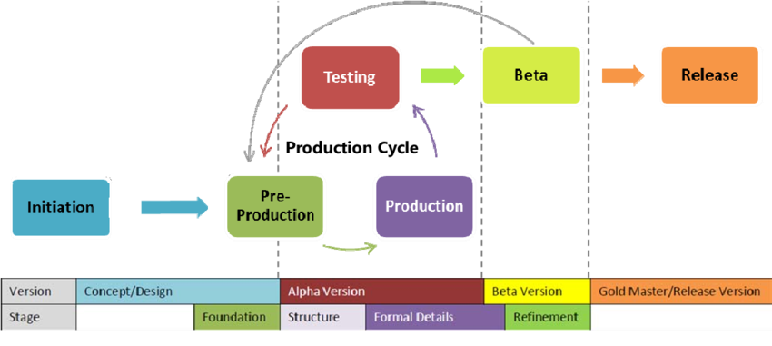

Figure: Game Development Life Cycle (GDLC) Model

GDLC Model is divided into six different phases:

## 3.2.1 Initiation

In this process which involves drafting a high level of the game concept. This phase processes involved: A. Building a story and script

A theme or concept of the game will revolve is defined here. The theme or concept is targeted to an audience of the specific age group. The main and side characters are decided after the plot is defined for every state of the game. The plots of the game divided into the script and it is made there is a continuation of the game from one level to another. B. Feasibility Study

A feasibility study is the possibility to develop the defined game above within the give constraints. All the requirement is gathered such as scope, platform, interface and other.

## 3.2.2 Pre- Production Phase

Pre-production is the first phase of the production cycle. It involves mainly game prototyping and game design. A working prototype of the game is created using the design concept which involves the core feature of the game such as fun elements, layouts, texture, and animation. Various tools used to create design elements are Adobe Photoshop and Adobe Illustrator.

1. Character Design

It is important to design a strong and convincing character that is suitable for the given context and looks visually appealing. Expressions and posture should also match with the theme of the game, especially role-playing game. In this project, the character of the game is drawn manually and convert to 3d model so that the modelling process is easier. The tools used for modelling character is Autodesk Maya.

1. Asset and Materials

Asset and Materials is part of 3d games. It is easier for modeller to put the layout which already have realistic on the texture. Tools used to create the asset is Sketchup. The following are example of asset and materials;

* + Buildings
  + Tree
  + Electric Pole
  + Roads

1. Background Designing

The background design is fully follow the true layout of the Virtual World. The bush and a lot of trees is randomly placed because the design seem same right away.

1. Texturing

The texture is given to increase the realistic of gameplay that can attract the player.

1. Animation

The animation is a process of giving a sequence of action of the character of the game. The flow of the game is not linear mesh methodology is used to give the animation, with the animation we can show the deformations like rib movement, Animation is further classified as motion capture animation and key frame animation.

1. Music and Sound

Apart from animation, music, and tone play a great role in enhancing the overall gameplay. The sound is used to show exaggerate the effect shown in the motion.

3.2.3 Production

Production phase comes when the prototype is already designed and approved. It is a process where the actual back end, as well as fronts, end programming is done, game assets are created and merge are together. Here the previously test interfaces are used and if they are not available then they create and add to the existing repository of the interface. The game is actually in a Game Engine which is general purpose game development tools to assist rapid game development. We need to decide which is the programming language and game engine to use in order to implement the code and develop the game. Usually, the 3d game engine that used in game developing is Unity 3d, the programming language used in that game engine is C# and Java. The production phase is also an iterative process in which after each iteration the formal detail like game balancing is refined by adding new features, resolving bugs and improving overall performance. Apart from that game is constantly polished to make it more challenging and fun elements are enhanced.

3.2.4 Testing

Testing is an integral part of the software development life cycle and it becomes of utmost importance when it comes to game development. As it has shown from past experience that games are the only software’s in which major bug fixes are reported. Due to the complex nature of the game would run perfectly but when played with intense care it would affect the gameplay. Game testing is performed in a well-structured manner for each and every games ranging from small games to a multiplayer game.

3.2.5 Beta Testing

It is performed by the tester outside the development team, a few groups of end users are given the feature complete game for beta testing and the feedback is noted to resolves the bugs. The main feature of beta testing is that the tester can explore every part of the game as the gameplay, music, and animation.

3.2.6 Release

In many situations due to some hard deadlines, it is possible to exhaustively test the game. So final version of the game is sometimes released which may contain one or two minor bugs. So the development team then solves the bugs and releases the bug fixes, update and patches for the game that is installed by the ends.

# **3.3 Requirement Analysis**

In developing 3D games, various aspects need to be addressed, among others, in terms of project requirements for the process to run smoothly. The project requirements are software requirements and hardware requirements.

3.3.1 Software Requirement

The main software used to develop this game is Unity 3d. This software is required to organized, animate the image and plug in coding to move the character in this game as well as the entire game. In addition, there is other software used in the process of developing this application. The other software used by this game is:

|  |  |  |
| --- | --- | --- |
| No. | Software | Description |
| 1 | Unity | Used to animate the game, scripting Coding and create the platform of the game. |
| 2 | Sketchup | Modelling 3d tools that used to model the asset environment. |
| 3 | Maya | Modelling tools to model, rigging and texturing character. |
| 4 | Abode Fuse | Modelling tools to model, rigging and texturing character. |

Table 3.1: Software Requirements

3.3.2 Hardware Requirement

In the process of developing this game, the hardware requirements are also needed. During the development process, hardware and software compatibility is important avoid undesirable problems. Among the tools that help simplify the application development process are:

|  |  |  |
| --- | --- | --- |
| No | Hardware | Description |
| 1 | Intel® Core™ i7-4510u CPU  2.00GHz | Develop the entire game, modelling, editing, scripting programme of the project |
| 2 | External Hard Drive 2 TB | Backup Data |
| 3 | Printer Canon MP258 | For document printing |

Table 3.2: Hardware Requirement

# **3.4 Game Design**

The development of the Sweetness of a Journey game has been using various type of approach. The approach that has been used are:

3.4.1 Instructional Approach

Through this approach, the instruction can give by text usage. The briefing instruction provided to help the user understand the content of this game. The description in this help module also uses the same method and briefly explains the mission that needs to be done by the user.

3.4.2 Help Approach

Through this approach also, users can know about this application by simply reading on the module. In this app also, users are provided with the instruction at the beginning of the game with this, it facilitates the user to understand the game's needs and information.

# **3.5 Navigation map (Data Flow Diagram)**

In developing this project, a navigation map was created to illustrate the continuity between one interface and one another. In addition, the navigation map also serves to give you an overview of what is contained in this project.

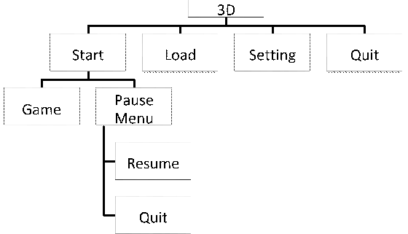

Figure: Navigation Map

# **3.6 Storyboard**

In developing games, storyboard should be prepared in advance before the application of this game. It is very important to facilitate the development of this application as a reference and it is used so that it is in line with the navigation map made. The storyboard is based on story that usually happen inside the campus. With this storyboard, the entire interface can be built from the beginning to the end.

# **3.7 Chapter Summary**

This chapter fully describes the methodology that used to develop the game, software and hardware requirement for this game, the approach used in this game, the navigation map to show the continuity the interface and the storyboard to show the flow game and the proof of the concept of this game. The GDLC is chosen based on the complexity of the game through the developing process. In the game design, it shows the navigation map. Navigation map used to show the flow of the game design starts from the main menu interface.

**4. IMPLEMENTATION AND RESULT**

# **4.1 Introduction**

System implementation is the process of defining how the game should be build, ensuring that the game is working in term of operational and meets its quality standard. During the implementation phase, a few tests for the game had been done. Testing is a process where executing takes place with intent to finding the errors. This chapter will explain about the implementation and testing of 3D simulation game.

## 4.1.1 Deployment and Configuration

In developing phase of this project, it used C Sharp programming language. To write the script, Visual Studio is the platform for developer to manage the code as the project will be.

The Microsoft Visual Studio has been used to write the code. For interface design, it used different software which is the main software, Unity 3D 2018.

## 4.1.2 Interfaces Design

User interface design is the design of computers, appliances and software application with the focus on the user’s experience and interaction. The goal in designing user interface is to make a great interaction between user and the application in term of efficiency, user-friendly, compatible of the system with target users. The interface should be understandable, easier to use with a proper arrangement of game flow.

# **4.2 Testing and Result**

Testing is one of an important phase in the development of the project. This phase works to test the system or application whether it fully function or vice versa. In this phase, there are three types of testing to test the system which is unit testing, integrate testing and system testing. Unit testing is carried out to verify the functionality of specific section code. Integration testing is to an exposed defect in the system interfaces and interaction between modules.

## 4.2.1 Games Functionality Test for Player

|  |  |  |  |
| --- | --- | --- | --- |
| **Step** | **Procedure** | **Expected Result** | **Result** |
| 1 | Start Menu | Display Main Menu | Success |
| 2 | Click on Option Button | Display Option Window | Success |
| 3 | Adjust Volume Slider | Volume increase or decrease | Success |
| 4 | Click on Back Button | Display Previous | Success |
| 5 | Click on Start | Starting the Game | Success |
| 6 | Click on Quit | Close the Game | Success |
| 7 | Mouse movement | Camera view of player | Success |
| 9 | Keypad (WASD) avatar movement | Avatar move in x-axis and y-axis | Success |

Table 4.1: Table Functionality Test

# **4.3 Chapter Summary**

The implementation of coding and testing of the system is discussed in this chapter. For creating high quality graphic and well AI system, all test cases must be tested carefully to ensure the intended result. Next, the main menu and flow of the game are discussed. Finally, the discussion related tested and evaluated of the game functionally.

**5. OUTPUT**

**3-D Tic Tac Toe**

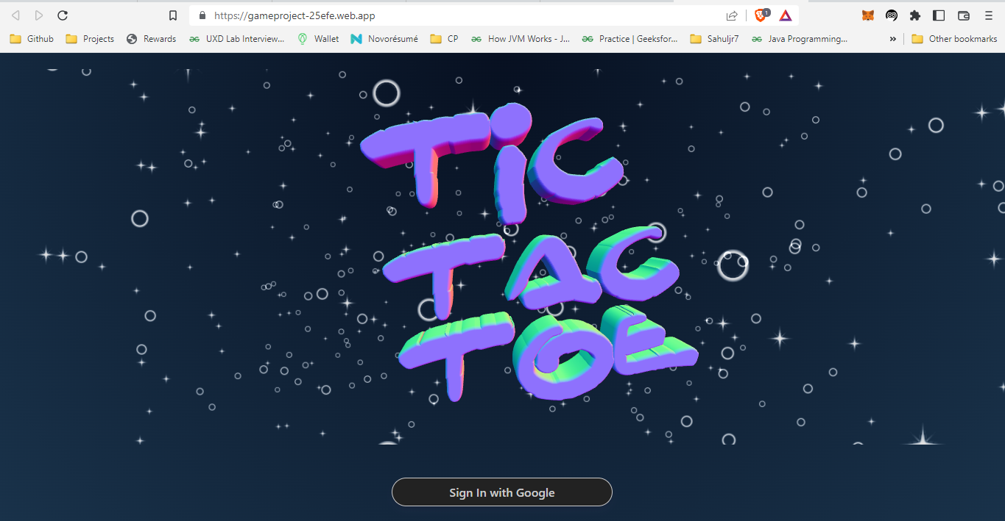

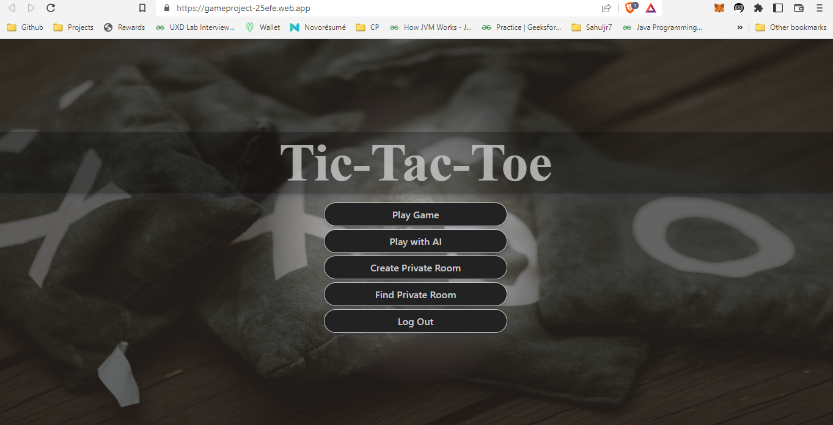

Play Game(Random Matchups)

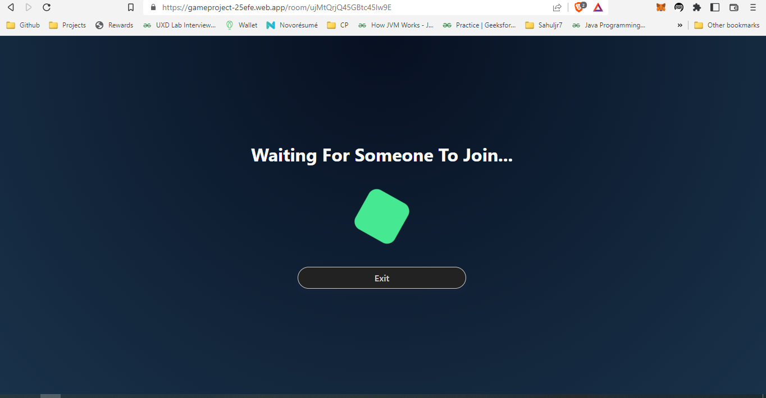

Play with AI

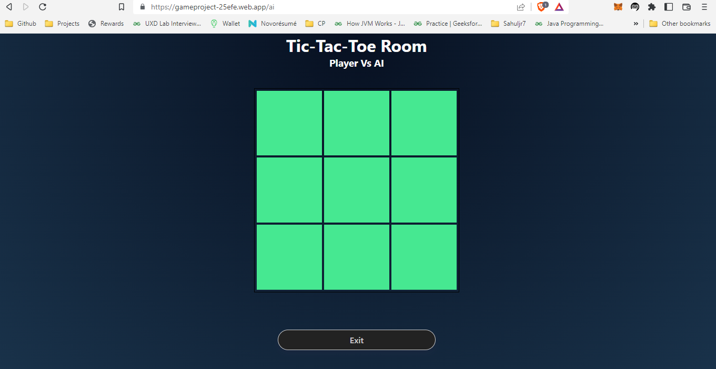

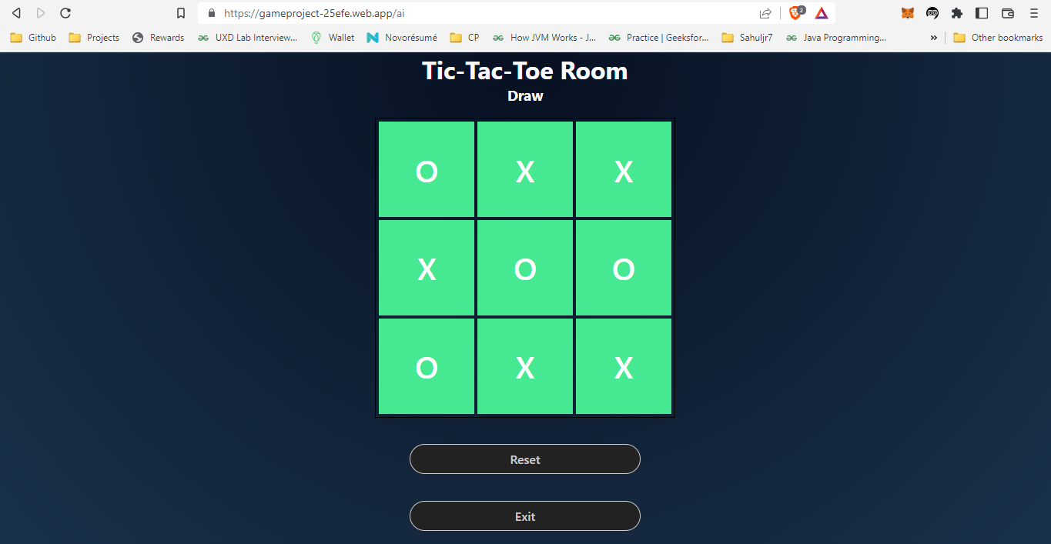

Create Private Room

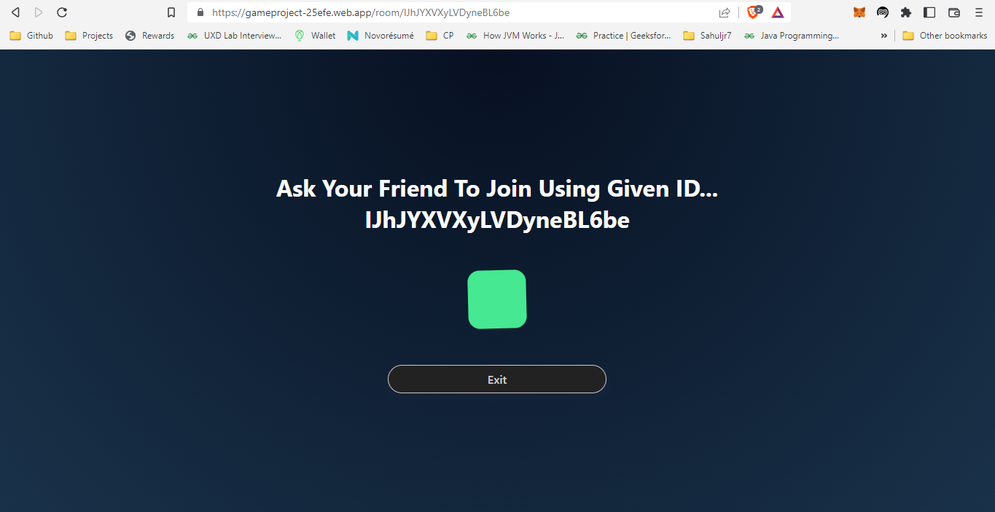

Find Private Room

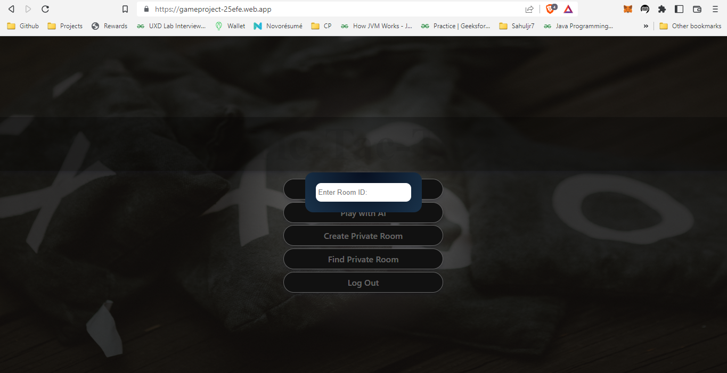

**5. CONCLUSION AND DISCUSSION**

# **5.1 Introduction**

In this chapter, the goal and objectives of the project is discussed and concluded. Other than that, this chapter also included the project constraints and possible future work that should be took in the future.

# **5.2 Project Contribution**

This game is developed for simulate the student life besides getting experience around Virtual environment in 3D form. It also tells a lot of information about three dimensional world and virtual experience. This application had achieved the objectives and all scopes had been fulfilled. The achievement of this project is:

* Player can move their avatar freely inside the game with virtual environment in 3D form.
* Player experience the simulation game on 3-D.
* Player know the layout of the 3-D Virtual World.

# **5.3 Result Discussion**

Generally, the project has been carried out and followed the objectives that had been stated in Chapter 1 previously. In this project, player will either successfully play this game. The result of this project is 3D simulation game are developing, design based on real campus and clean from any violent that can influence and affecting the player.

# **5.4 Limitation**

There are several problems and limitations while developing this project. These are the problems and limitations in conducting this study are:

* The high quality of graphic cannot be creating because of computer lagging.
* The map of the environment is limited due to low PC performance.
* The high quality of artificial intelligence (AI) cannot be implement.
* The game is for PC only.

**5.5 Recommendation**

Although the application works properly and follows the milestones of project respectively, there exists some changes can be taken for better performances. The constraint as described before this can be corrected and improve the quality for the future. The developer must come up to date with the current technology to ensure the application that developed will meet the standard. The function of loading and saving the current progress that have been played must be created so that player can continue their journey inside the game.

# **5.6 Outcome Analysis**

The minimax algorithm performs a complete depth-first exploration of the game tree. It recursively calls itself until a winning state of any agent is found or the grid is full. If the maximum depth of the tree is m and there are b legal moves at each point, then the time complexity of the minimax algorithm is O (bm). The space complexity is O(bm) for generating all actions at once. For 3X3 board, the possible number of moves is (3 * 3)! = 9! If the board size is increased to 4X4 there is exponential growth and we experience an explosion of computational time. This means we now get 16! Possible states which is an incredibly large amount. So, we can estimate that computational time will be million times higher than 3X3 board. Hence, the time cost is totally impractical, making this algorithm infeasible in 4X4 board, but it serves as the basis for the mathematical analysis of games and for more practical algorithm.

# **5.7 Outcome**

# Our project name is 3-D Tic-Tac-Toe game. This game is very popular and is fairly simple by itself. It is actually a two player game. In this game, there is a board with nxn squares. In our game, it is 3 x 3 squares. The goal of Tic-Tac-Toe is to be one of the players to get three same symbols in a row - horizontally, vertically or diagonally - on a 3 x 3 grid.

So, basically we have created a 3D Multiplayer Game where the user can play with AI and with other players using random matchups and creating private rooms. We want our game to bring the player community together.

# **5.8 Future Scope**

As technology advances, we will see games become a completely immersive experience. Imagine fully encompassing make-believe worlds that you control with your mind and body. Advances in technology and the rapid growth of the esports gaming community will help shape the future of gaming.

# **5.9 Conclusion**

By the end of this study, this project is expected that game can be a new way to promote Virtual World to people. As we all know, each university have their own portal website to put their information for people getting information. This project may not replace the function of the portal website but can be another interesting way to promote and put information. After playing this game, people can relate the real layout with the 3D layout of the campus. Furthermore, the game is very friendly-user with guide that can be understand easily.

With the basis of minimax algorithm for mathematical analysis alongside speeding up the computation by alpha beta pruning concept and optimizing the utility function using heuristic function, the 4x4 tic tac toe game was developed. Increasing the size of this game would create a huge time complexity issue with the same algorithm and techniques, for which other logics must be further researched.

# **REFERENCES**

1. Mukherjee, Souvik. “Introduction: Video Games and Storytelling.” Video Games and Storytelling, 2015, pp. 1–21., doi:10.1057/9781137525055_1.
2. “Embodying Character in Storytelling.” Performing Story on the Contemporary Stage, 4 Feb. 2013, pp. 9–10., doi:10.1057/9781137356413.0005.
3. Huber, Amy M. “Visual Storytelling.” Telling the Design Story, pp. 101–129., doi:10.4324/9781315226132-6.
4. Pitcher, Jenna (9 October 2013). "Grand Theft Auto 5 smashes 7 Guinness World Records". Polygon. Vox Media. Archived from the original on 9 October 2013. Retrieved 9 October 2013.
5. Jackson, Leah B. (June 9, 2014). "E3 2014: The Sims 4 Release Date Announced". IGN. j2 Global. Retrieved June 9, 2014.
6. Wagner, Jayce (June 13, 2017). "In The New 'God of War 4' Trailer, Kratos Is Old, Grizzled, And as Brutal As Ever". Digital Trends. Designtechnica Corp. Archived from the original on April 13, 2018. Retrieved June 22, 2017.